Budget Rent A Car 
of British Columbia

Global Information System

Credit Card Interface Business Design

Version 2.00

Note: The information contained in this document is confidential and may not be disclosed to any parties outside of Budget Rent a Car of British Columbia without written consent by one of its officers.
Copyright (C) 2000 Budget Rent a Car of British Columbia
Table of Contents
1. Functional Area Business Design 1
1.1. Credit Card Authorization 1
1.1.1. Process Description 1
1.1.1.1. Items Covered Under Other Business Designs 3
1.1.1.2. Credit Card Process Flow 4
1.1.1.2. Credit Card Process Flow 4
1.1.1.3. Close of Business Day Process Flow 5
1.1.2. Functions 7
1.1.2. Functions 7
1.1.2.1. Credit Card Transactions 7
1.1.3. Screens 13
1.1.3. Screens 13
1.1.3.1. Close of Business Day 13
1.1.4. Reports 16
1.1.5. Background Processes 17
1.1.5.1. Transfer of Eigen Balances 17
1.1.5.2. Build Credit Card Balancing Totals 19
1.1.6. Data Model 21
1.1.7. Test Scenario List 21
1.1.8. Controls & Audit Trails 22
1.1.9. Security Requirements 23
1.1.10. Eigen Assumptions 24
2. Revision History 25
2.1. Version 2.00 25

Functional Area Business Design

Credit Card Authorization

Process Description
This interface is required to automatically process deposit payments, pre-authorizations, final payments (purchases) and refunds (returns) made using a credit card directly from the GIS system. GIS will not cancel pre-authorizations. For all credit card transactions, the interface must return information indicating whether the transaction was successfully processed or has been rejected. Initially, the credit cards to be processed through this interface are:
- VISA
- Master Charge
- American Express
- Diner’s Club
- Japanese Credit Bureau
Previously, the above credit card transactions were performed through the CIBC Merchant’s Edge program. CIBC forwards Master Charge transactions to Canada Trust. The proceeds from all transactions are deposited into Budget’s CIBC account.
Debit cards, Novus/Discover, Sears and BRAC credit cards will continue to be processed as they are now. That is, there will be no automated approval in GIS, all authorization processing will be outside of GIS. A screen will be provided in GIS to allow entry of approval information for these transactions.
A reservation or contract can be associated with a number of electronically processed credit card transactions, while a sales accessory contract will only ever have one payment or refund. Credit card transactions within GIS include:
- Payment of a reservation deposit.
- Refund of a reservation deposit.
- No show payment (Maestro guarantees).
- Pre-authorization of an estimated rental amount when the contract is opened.
- Additional pre-authorization for changes to the open contract.
- Completion of a pre-authorization, or payment, at check in.
- Additional pre-authorization at check in, when original pre-authorization is insufficient to cover the final amount.
- Additional payments/refunds for adjustments after the contract is checked in.Payments and refunds for sales accessory contracts.

For more information on the above transactions, refer to the following business design documents:
- Reservations
- Maestro Reservations (for No Show process)
- Contracts Part 1
- Hand Held Check In
- Foreign Contract Check In
- Contract Adjustments or Sales Accessory Contract business design documents.
- Contract Print (for print format for credit card transactions)
Credit card information will be captured by swiping the credit card or by manual entry. Credit card information will be manually entered when the physical credit card is not present, as in the case of a reservation deposit taken over the phone, or when swiping the card is unsuccessful. For the major credit cards, the type of the credit card will be determined based on the first four digits of the credit card number and the length (this will also be done for other credit card types if they also use unique known ranges in the first four digits). However, the user may still override the type if the type defaulted is incorrect.
When the credit card connection is down, GIS will allow entry of a manual approval (using the same screen as used to enter non-major credit card approvals). The CSR will manually obtain approval using the existing CIBC terminals at each location, and then key the approval information into GIS. Eigen’s OCX will not be used to automatically approve pre-authorizations up to the floor limit.
Because of the difference in time between a credit card transaction (e.g. payment) and the completion of the GIS transaction (e.g. check in), a log will be kept of each successful credit card purchase or return transaction (approved thru Eigen) as soon as approval is received. This will allow reporting of approved credit card transactions, which were never fully processed into GIS because the GIS transaction failed or was exited prior to completion, for reconciliation purposes and to support corrective action.
Every night, soon after midnight, the business day is closed and funds are released for deposit for all locations by an automatic process. This process initiated at Budget BC’s airport location, by the manager or supervisor, causes a custom settlement process to run at the Eigen switch (the 3rd party vendor offering connection services to CIBC). This custom settlement process issues a settlement transaction for each Budget BC PC which is able to process credit card transactions through Eigen. The Eigen switch will provide balancing totals, by credit card type, for each PC settled each day. Following close of day, these totals will be electronically retrieved from Eigen and used to balance to Budget totals captured in GIS.
Two reports will be used to reconcile Budget with Eigen and determine why any totals do not balance as follows:
- Credit Card Balancing report - reports individual PC credit card totals and highlights any out of balance situations between Budget and Eigen. For each PC and credit card type, the report will also allow viewing of the Budget credit card transactions for that business day.
- Credit Card Imbalance report - shows automatically approved credit card payments and returns which were never fully processed into GIS.
A GIS report (Location EOD Reconciliation report) will be produced daily for reconciling deposits listed on CIBC’s Bank Statement. The report will include location totals by day and payment type (i.e. Canadian and US cash, mail refunds, debit card, each type of credit card, and direct bill).
Note: Each Budget location has a different merchant ID for each major credit card type. Every credit card processing PC will have a unique terminal ID assigned by CIBC. CIBC identifies the merchant ID, using the unique terminal ID and credit card type, and reports bank deposit amounts at the merchant ID level. All credit card transactions for the above credit cards automatically approved in GIS will reference a terminal ID. A unique terminal ID will be assigned by CIBC for no shows and the No Show process must use this terminal Id. Other terminal Ids are not authorized by CIBC to accept No Show transactions.

Items Covered Under Other Business Designs
The design of the screens used for entry of credit card information will be covered by the business design for the respective GIS function.
The format for printing credit card transactions in printed reservations, contracts and sales accessory contracts is described in the Contract Print business design document.
The accounting processes following Close of Business Day are described under the Accounting Interface business design document.

Credit Card Process Flow
The following diagram illustrates a basic flow for processing a credit card in Reservations and Contracts. Final details of completing payments and pre-authorizations shown in the process flow are described in the Reservation, and Contract business designs.

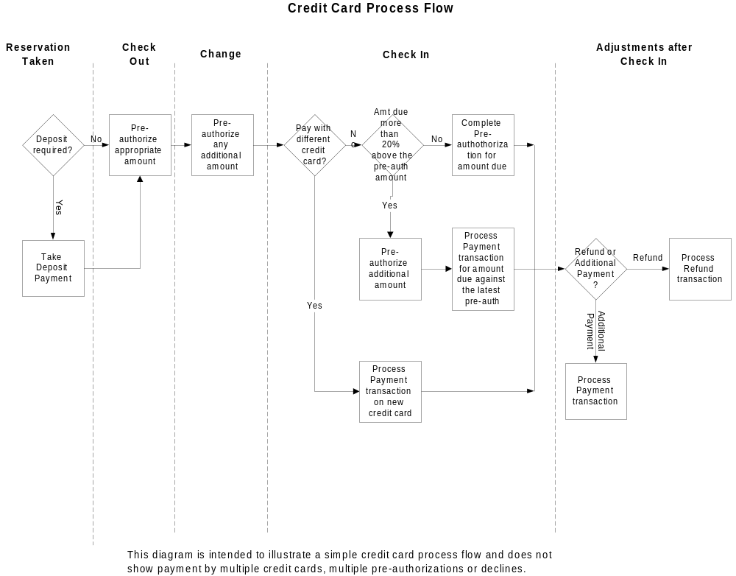

Close of Business Day Process Flow
The close of business day will be initiated by the airport for all Budget BC locations. Since all GIS contract processing must be suspended during the close of business day, the airport will initiate the closing of the day at a time when they are not busy servicing customers. Closing will be started as soon as possible after midnight each night.
The following diagram shows the close of day process flow. A description of each process in the flow is included below the diagram.
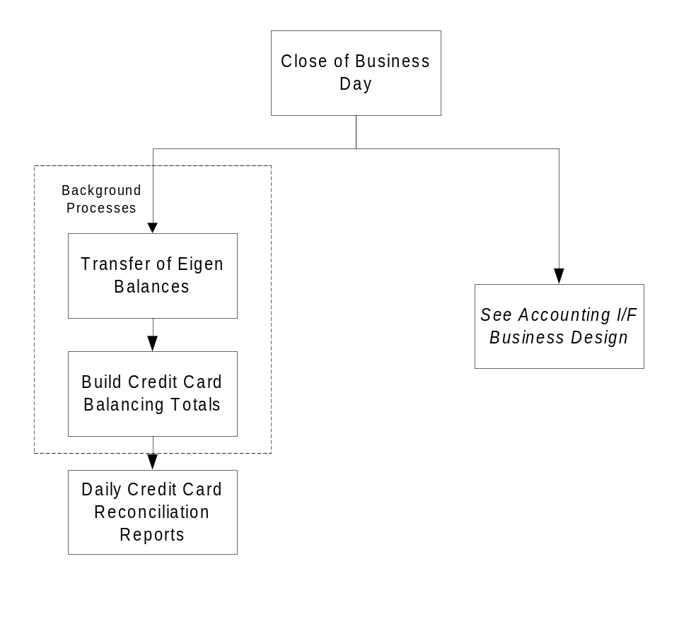
- Close Business Day process
This process is initiated by a user who is authorized to access the Close Business Day screen. The Close Business Day process will:
- Start the settlement (central balancing) process for Budget at Eigen. Eigen’s central balancing process closes off electronic credit card batches to CIBC for each terminal ID (PC) and stores balances and transaction counts for each PC and credit card type in a directory at Eigen.
- On successful completion of the settlement process will:
- Close the current business day.
- Open the next business day.
- Reset daily contract totals for all direct bill accounts to zero.
- Start background process to transfer the day’s Eigen balances and save Budget and Eigen counts in GIS.
- Start background process to generate the A/R and G/L daily posting files (see Accounting Interface business design for details of this process).
- Notify the user accordingly that either the Close of Day is successful or output a message indicating why the process failed. Once the Close of Day has successfully completed, the airport can process contracts for the new business day.
- Transfer of Eigen Balances
- Eigen balances and counts for the day for each PC and credit card type are retrieved and stored on Budget’s file server.
- Build Credit Card Balancing Totals
- This process sums the same totals by PC and credit card type based on information in the GIS and stores this with the Eigen totals (retrieved in the previous step) in the GIS database.
- Daily Credit Card Reconciliation Reports
- The Credit Card Balancing and Credit Card Imbalance reports will be manually requested and used to verify that Eigen and Budget totals match. Any differences must be explained and where necessary correction action taken.

Functions

Credit Card Transactions
Purpose
Credit card information can be captured by swiping the credit card or by manual entry (although some functions may use previously recorded credit card information). Normally the following credit cards will be electronically processed; VISA, MasterCard, American Express, Diner’s Club and Japanese Credit Bureau, but manual entry of credit card approvals is required when the Eigen connection is down. A log of all the successful credit card purchases and returns, and the response back from CIBC/Eigen must be kept (this includes completion of pre-authorizations, payments and returns). This log is updated immediately approval is received from Eigen, not when the GIS transaction is completed which may be several minutes later.
The following are guidelines for designs using the interface. Not all functions will be supported by every design. Controls identify fields that will have to be supported on screens using the credit card interface.
Navigation
N/A
Functions
Credit Card Swipe The credit card swipe process, which reads the credit card information from the swipe, will time out if the card is not swiped within the time out period (timed from the time it has been indicated that a card is to be swiped). A timeout will also occur if complete credit card information is not received within the time out time after receipt of the first character of the swiped information. The time out time will be user specifiable in a designated entry in the Lookup table in GIS.
After the operator has successfully swiped a credit card, he/she will be requested to enter the last 5 digits of the embossed credit card number to verify the number. The credit card will be rejected if the last 5 digits of the embossed credit card do not match the last 5 digits of the swiped credit card number.
Pre-Authorize: Format and invoke the Eigen OCX for a pre-authorization transaction (Eigen transaction code “11”). The pre-authorization amount is determined by the function requesting the pre-authorization.
Complete: Format and invoke the Eigen OCX for a completion transaction (Eigen transaction code “07”). A completion transaction processes the payment using one or more successful pre-authorizations. The payment final amount may be up to 20% greater than the total amount for previous pre-authorizations. If the final amount is more, an additional pre-authorization must be done for the difference between the total amount previously pre-authorized and the final amount. If the contract has multiple pre-authorizations, the latest pre-auth is passed with the completion transaction. On approval of the completion, all the pre-authorizations are flagged as used. A completion transaction may be made by either the check out location or by a different Budget BC location.
Payment: Format and invoke the Eigen OCX for a purchase transaction (Eigen transaction code “01”). A purchase transaction is not associated with any pre-authorizations and is processed immediately. The amount is determined by the function requesting payment.
Refund: Format and invoke the Eigen OCX for a return transaction (Eigen transaction code “04”). The amount is determined by the function authorizing the return.
No Show: Format and invoke the Eigen OCX for a no show transaction (Eigen transaction code “08”). Only the No Show process issues no show transactions (note: this is a background process, not online). The no show process will determine the amount of the payment. The server used for no shows must be set up with the specific terminal Id assigned by CIBC for that purpose. No other terminal Ids are allowed to do no shows.
Controls
Field | Source | Req* | Validation | Comments
Credit Card Type |  | Y | Display warning if credit card type indicated by first four digits and length, and credit card type selected do not match. | Selected from list of valid credit card types. If not selected, for major credit cards the credit card type will be determined from the first four digits of the credit card number and the length (known ranges and lengths are obtained from Credit Card Range table). In future, this may be possible for other credit cards depending on whether they use unique first four digit ranges.
Credit Card Number |  | Y | If card type has numbers with a mod 10 check digit (determined from Credit Card Type, Mod 10 Check), credit card number must pass mod 10 check.
Last 5 digits of Credit Card |  | S | Must equal the last 5 digits of a swiped credit card number. | Required if credit card is swiped. (This field will not be stored on the database.)
Expiry Date |  | Y | Must be a valid date in format “MMYY” and month must be greater than or equal to current month.
Last Name |  | Y
First Name |  | Y
Transaction Type |  | Y |  | Set in GIS code depending on screen and request made by user, and passed to Eigen. Not displayed on screen. See Functions above for Transaction Type values used by GIS.
Amount |  | Y | Positive amount.
Authorization Number |  | S | If electronically authorized, returned by Eigen.  For a manual pre-authorization, must be entered if the amount is greater than the floor limit. | Authorization number will only be entered if the pre-authorization/ purchase/return is not processed through Eigen. This situation would happen if the credit card was authorized through a CIBC terminal or over the phone. Approval codes passed back by Eigen only display for previously completed transactions.
Terminal ID |  | S |  | Set by GIS. Only populated if authorized through Eigen. Not displayed on screen.
Transaction Date & Time |  | Y |  | Set by GIS to time from GIS workstations. Only displayed for previously completed transactions.
Remarks |  | S |  | Set by GIS from information returned from Eigen (declined transactions are not saved). Only populated if authorized through Eigen. Not displayed on screen.
Response Code |  | S |  | Set by GIS from information returned from Eigen. Only populated if authorized through Eigen. Not displayed on screen.
ISO Response Code |  | S |  | Set by GIS from information returned from Eigen. Only populated if authorized through Eigen. Not displayed on screen.
Swipe Flag |  | S |  | Set to “S” (swiped) if passed to Eigen as a swiped transaction, otherwise set to “M” (manual). Only populated if authorized through Eigen. Not displayed on screen.
* Required: Y – always required
S – sometimes, may be either required or optional, depending on other data
‘ ‘ – always optional
Technical Notes
- The technical design must provide a mechanism to initiate the swiping of credit card information so that GIS can differentiate between credit card information manually entered vs. swiped
- The screen to allow entry of manual approval will always be displayed when a credit card transaction is rejected via the Eigen interface even if the error suggests the transaction should not be manually approved.
- A credit card transaction can only be passed to Eigen as a swiped transaction if full track 2 information is available at the time of the transaction (i.e. the credit card was immediately swiped for that credit card transaction – as mandated by the bank, full track 2 information is not maintained anywhere in GIS). Note that when a card is swiped immediately for that credit card transaction, the full track 2 information must be passed to Eigen.
- For full details of how to use the Eigen OCX, see Eigen’s document titled “Dsintx ActiveX Component, Interface Development Guidelines”.
- The log of all the successful credit card purchases and returns is kept in the Credit Card Transaction table.
- The Response Code is stored in the Trx Receipt Ref Num column in the Credit Card Transaction and respective credit card payment table. Credit Card Transaction, Function is set to the same value that is subsequently inserted in Business Transaction, Transaction Description for the GIS transaction. Other column names are self explanatory.
- When finding the matching Credit Card Transaction for a credit card payment at completion of the GIS transaction, in order to set the Added To GIS flag on, only search Credit Card Transaction records where the Added To GIS flag is off and find the record where the following fields match the credit card payment:
- RBR Date
- Terminal ID
- Credit Card Number
- Amount
- Authorization Number
If there is more than one matching record, set the flag on in the latest record (determine latest record using field System Datetime).

Screens

Close of Business Day
Purpose
The purpose of this process is to close the business day (in GIS) for all of Budget BC. The process is manually initiated from the Close of Business Day screen. This screen is restricted to a specific user group which can be used by the supervisor at the airport location. The supervisor must ensure that all CSRs exit GIS during execution of the on-line Close of Business Day process.
The Close of Business Day will initiate settlement at Eigen. Once the settlement closes the day’s credit card batches, the Close of Business Day will roll over the Revenue Business day (RBR day) to distinguish transactions processed on one day from those on the next, and return control to this screen.
Navigation
N/A
Functions
The Close Business Day will function as follows:
- A screen will display on the Close of Business Day screen, asking the operator to confirm their intention to close the Business Day and ensure that no users are using the GIS system.
- On clicking the Close Business Day button, a dialog box will display on the Close of Business Day screen, asking the operator to confirm that no PCs are processing GIS contracts or reservations. If the user responds ”Yes”, a message is sent to the Eigen Switch to initiate Central Balancing.
- For Central Balancing, Eigen will process a settlement transaction for each PC that is authorized to process credit card transactions through Eigen. This entire process takes place at Eigen and the process will not communicate with the Eigen OCX on each PC (all PCs, except those at the airport, are turned off each night and are not available to Eigen). Each settlement produces a set of CIBC totals for the day and a corresponding set of Eigen totals. Eigen will verify that the Eigen and CIBC totals agree and handle any out of balance situation between Eigen and CIBC. The Eigen totals will be stored in a directory at Eigen to which Budget has access.
- When all settlement transactions have been processed, Eigen will return a message to the Budget BC, Close of Business Day function which will then:
- Close the current business day (insert system time in Budget Close Datetime and operator Id in Closed By in the the RBR Date record for the closed business day).
- Create RBR Date record for the new business day.
- Reset Daily AR Credit Authorization, Daily Contract Total for all direct bill accounts to zero (i.e. in all rows in AR Credit Authorization table).
- Initiate the background processes to transfer the day’s Eigen balances and save Budget and Eigen counts in GIS (see below under 1.1.5 Background Processes).
- Initiate the background process to generate the A/R and G/L daily posting files (see Accounting Interface business design for details).
- Notify the user accordingly that either the Close of Day is successful or output a message indicating why the process failed.

Controls
Field | Source | Req* | Validation | Comments
RBR Date | System Values, RBR Date | Y | Display only | Upon completion of the Settlement Process;  1) The date will be updated with the RBR date of the new business day.  2) The Close Day button will be greyed when the RBR date is the same as the system date.
* Required: Y – always required
S – sometimes, may be either required or optional, depending on other data
‘ ‘ – always optional
Technical Notes
None
Future Close of Day Options
The close of day process requires the supervisor to physically ensure that all other users have exited GIS. A future enhancement to the Close of Business Day process would be to check whether any other users are signed on to GIS and only allow the Close of Business Day to proceed when all other users have exited GIS.

Reports
The following reports will be used to support the credit card reconciliation between Budget and Eigen, and between Budget and the bank deposits. The specifications for these reports are included with the GIS report specifications.
Reconciliation between Budget and Eigen:
- Credit Card Balancing Report
- Credit Card Imbalance Report
Reconciliation between Budget and the bank deposits
- Location EOD Reconciliation Report

Background Processes

Transfer of Eigen Balances
Purpose
This process retrieves the latest settlement file from a directory at Eigen and stores the file on Budget’s file server. The file contains balances and counts by credit card type and terminal Id.
Input Parameters
None
External Inputs
- Eigen settlement file containing balances and transaction counts by terminal ID and credit card type.
A settlement record is created for every assigned Budget BC terminal Id and credit card type combination regardless of whether or not there were transactions for that combination. There will also be a record for each terminal Id for credit card transactions for which Eigen was unable to identify the credit card type. The amounts and counts in these records will normally be zero. If a terminal Id which has not been assigned is used, then the corresponding records will be inserted for that terminal Id. The downloaded file will have a linefeed between successive records (although when manually downloaded in a rerun situation it is also possible to get a CR, linefeed if the respective parameter is not correctly specified in the FTP which downloads the file).
Each settlement record contains the following data:
- Terminal ID
- Terminal ID (the first two fields both contain terminal ID)
- Credit Card Type (Eigen’s credit card type code)
- Net amount for terminal and credit card type (i.e. purchase amount less return amount)
- Purchase amount for terminal and credit card type
- Purchase transaction count for terminal and credit card type
- Return amount for terminal and credit card type
- Return transaction count for terminal and credit card type
- Reject amount for terminal and credit card type
- Reject transaction count for terminal and credit card type
Eigen stores the settlement file with a filename based on date (up to midday uses date of prior day, after midday uses current date) so that Budget can recognize the file with the most recent totals.
External Outputs
- Archived Eigen settlement file
- Filename of archived file
Frequency
This process is initiated following successful completion of the online Close of Business Day process.
Detailed Description
This process will retrieve the latest settlement file from the Budget settlement directory at Eigen and store it in an archive directory containing all the settlement files that have been downloaded. The date in the filename for the latest settlement will be determined from the current time. If the time is less than midday use yesterday’s date, otherwise use the current date. If there is already a file with the same name in the archive directory store the new file with a sequence number suffixed to the filename to make it unique (the file with the largest sequence number will be the latest file retrieved). As Eigen can take a short while to generate the settlement file, the retrieval will be repeated at short intervals up to 12 times until the file is successfully retrieved. On successful completion the filename assigned to the file when it is stored in the archive directory will be passed as a parameter to the Build Credit Card Balancing Totals process..
Technical Notes
- This process will FTP the file from Eigen to Budget. A password will be required to access the Eigen directory.
- Procedures must be in place to rerun this process to re-retrieve either the latest or a prior day’s file in the event of loss of a file.

Build Credit Card Balancing Totals
Purpose
This process reads the Eigen settlement created by Transfer of Eigen Balances, and accumulates the corresponding Budget counts and balances from the payment transactions in the GIS database. Both the Eigen and Budget figures are stored in the GIS database by terminal Id and credit card type.
Input Parameters
The only input parameter is:
- Filename of archived file
External Inputs
- Archived Eigen settlement file
External Outputs
N/A
Frequency
This process is initiated following successful completion of the Transfer of Eigen Balances process.
Detailed Description
This process will read the Eigen settlement file for the requested day, accumulate the corresponding Budget BC counts and balances, by terminal Id and credit card type, from the payment transactions in the GIS database and store both the Budget and Eigen figures in the Daily Terminal Total table.
Output batch start (with filename of settlement file being processed) and batch end messages to the Batch Error Log for this process. In addition, output a message to the Batch Error Log for any occurrence of the following conditions:
- No records in the settlement file.
- Record encountered with an unknown terminal Id (record will be rejected).
Technical Notes
- Procedures must be in place to rerun this process for either the latest day or a prior day if required.
- Must handle the two possible separators (i.e. linefeed, or CR and linefeed) between successive records in the settlement file.
- Payment tables used in accumulating Budget credit card totals are:
- Reservation Dep Payment and Reservation CC Dep Payment
- Contract Payment Item and Credit Card Payment
- Sales Accessory Sale Payment and Sales Accessory CrCard Payment

Data Model
See the Credit Card Interface subject area in the GIS ERWin data model.

Test Scenario List
Scenario Number | Scenario Description
Reservation
 | Make a reservation, requiring a deposit, through Reznet. Authorize the deposit payment at the respective location..
 | Take a reservation with a deposit at a location.
 | Cancel a reservation, which will require a refund of a deposit, through Reznet. Refund the deposit at the respective location..
 | Cancel a reservation, which will require a refund of a deposit, at a location.
Contract
Open/Check Out:
 | Open/check out a contract with a credit card pre-authorization.
 | Open/check out a contract with a deposit and a pre-authorization for the balance of the expected rental charges.
 | Open/check out a contract with a deposit and a pre-authorization for the balance of the expected rental charges, then void the contract.
 | Open/check out a contract with a credit card pre-authorization when the authorization connection is unavailable and then enter a manual pre-authorization.
 | Open/check out a contract with a reservation deposit, refund the reservation deposit and pre-authorize the expected rental charges on another credit card.
Change:
 | Make a change to a contract requiring an additional pre-authorization.
 | Make a change to a contract with an additional deposit and pre-authorization.
Check In:
 | Check in a contract with a completion payment against the credit card used to pre-authorize the contract where rental charge is less than 20% larger than the total amount pre-authorized.
 | Check in a contract with a completion payment against the credit card used to pre-authorize the contract where rental charge is greater than 20% larger than the total amount pre-authorized.
 | Check in a contract with a completion payment using a different credit card from the one used to pre-authorize the contract.
 | Check in a contract with a part payment against the credit card used to pre-authorize the contract and the remainder against another credit card.
 | Check out using a credit card at one location, check in using same credit card at a different location.
Adjustment:
 | Process a contract adjustment which requires an additional credit card payment.
 | Process a contract adjustment which requires a credit card refund.

Controls & Audit Trails
The following controls are implemented for credit card processing:
- For swiped credit cards, the user will be asked to enter the last 5 digits of the credit card number to verify the credit card.
- For credit cards swiped at the time of the transaction, audit information from the card is passed to CIBC. Note that this audit information is not (and must never be) captured on the GIS database.
- A history of all successful credit card completions, payments and returns processed through Eigen/CIBC must be kept in GIS.
- Eigen outputs a log on each PC, using the Eigen OCX, containing a record of all the credit card transactions passed to Eigen from that PC. The log output by the Eigen OCX will “X” out the centre of the credit card number and all the audit information in the record of each transaction. Thus if anyone was to look at the log, this information will be unavailable. In addition, the log files will be cleared from each of the respective end-user PCs on a nightly basis and stored on a server at Budget BC’s head office.
- Both Eigen and CIBC keep a log of all the credit card transactions they process for Budget which can be used to resolve reconciliation problems.
- The operator id, and the date & time that the Business Day was closed will be stored for each RBR date.

Security Requirements
Screen / Process | Restricted To:
Close of Business Day | Customer Service

Eigen Assumptions
- If one of the connections is down (CIBC & Eigen, Budget & Eigen), Budget will process credit card transactions using the CIBC terminal(s) at each location. If the connection is up, the Eigen OCX will be used to process all major credit card transactions regardless of the floor limit. It is assumed that:
- the Eigen switch will be able to notify the Eigen OCX that the connection between Eigen and CIBC is down
- the Eigen OCX will be able to notify the GIS that either the connection between Eigen and CIBC or Eigen and Budget is down
- the Eigen OCX can be configured so that it will not automatically pre-authorize amounts up to the floor limit.
- Central balancing will be modified so that communication to the individual Budget BC PCs (which perform credit card transactions) for settlement purposes, is not required. A Budget process will pull Eigen’s and CIBC balances from a directory at Eigen after all settlements are completed. It is assumed that:
- information transfer between Eigen and Budget will consist of a message to initiate the central balancing process and after that the settlement communication will be between the Eigen switch and CIBC with Eigen notifying Budget of central balancing completion.
- Eigen’s switch will have a record of the Budget terminal ids to settle with CIBC.
- The Eigen OCX will allow credit card transactions for any amount from 1 cent upwards.
- Identifying where out of balance situations could occur, who and how each situation will be resolved can be documented in procedures.

Revision History

Version 2.00
- Clean up documentation and make consistent with the GIS standards.

